Hi Team,

We are trying to run a script for scrapping that uses the undetected chrome browser. To use that library we need google-chrome and chromedriver updated to their latest version 110.0.5481.100. Also, we need google-chrome to be set to headless browsing, so it doesn’t need any GPU.

We have already tried to install this configuration on local and root servers, but it is showing us different errors.

Local server: 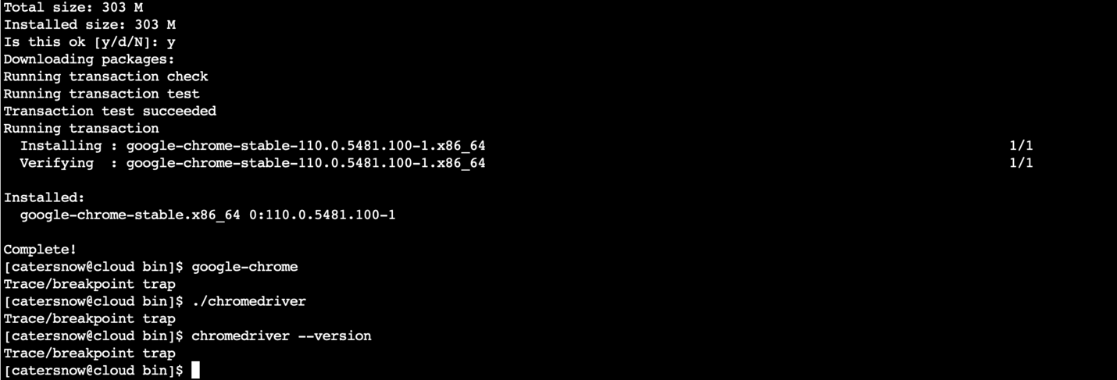

Root server:

Please solve this issue ASAP. Thanks